# Lock Stock & Barrel

By Dylan Matthews

Contents

Lock Stock & Barrel 1

Description 3

Screenshots of general 4

Error Handling 10

Specifications 15

Diagrams 16

prjLockStock Class Diagram 16

Use Case Diagram 17

Flow Chart 18

Help 19

On start 19

For add stock 19

For add keys 19

For add remotes 19

For add Batteries 19

For add locks 20

For add shop 20

For add repairs 20

For back to home screen 20

For sell stock 21

For sell keys 21

For add remotes 21

For add Batteries 21

For add locks 21

For add shop 21

For add repairs 21

For back to home screen 22

For view stock 23

Keys 23

Remotes 23

Batteries 23

Locks 23

Shop 23

Repairs 23

Back to home screen 23

## Description

Lock Stock & Barrel is a shop that sells keys, remotes, batteries, repairs, locks and general shop stuff.

We were tasked to do this and make a neat and easy interface. The program allows you to add stock to: keys, remotes, batteries, repairs, locks and general shop stuff. Also to sell stock and give prices of: keys, remotes, batteries, repairs, locks and general shop stuff. Also to view the stock of: keys, remotes, batteries, repairs, locks and general shop stuff.

## Screenshots of general

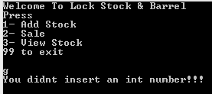

A welcome screen with error handling

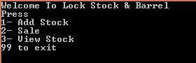

A home menu

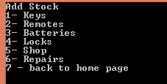

Add stock menu

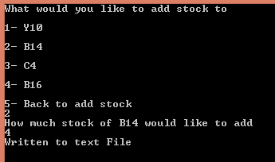

Add keys menu

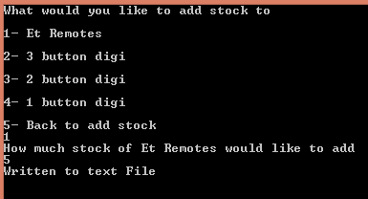

Add remotes menu

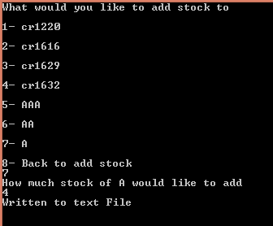

Add batteries menu

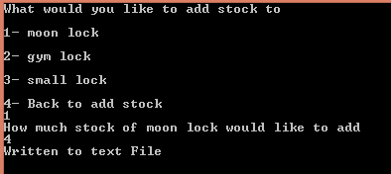

Add locks menu

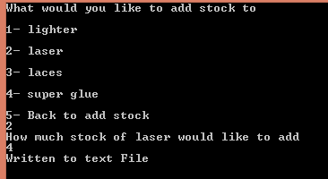

Add shop menu

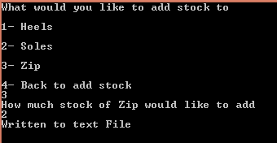

Add repairs menu

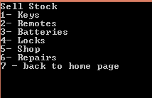

Sell stock menu

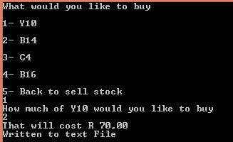

Sell keys menu

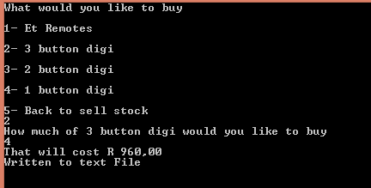

Sell Remotes menu

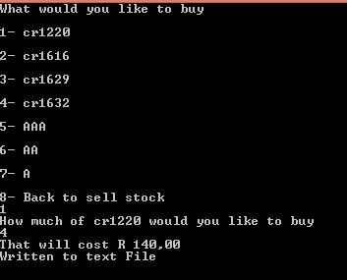

Sell Batteries menu

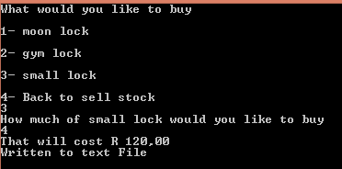

Sell locks menu

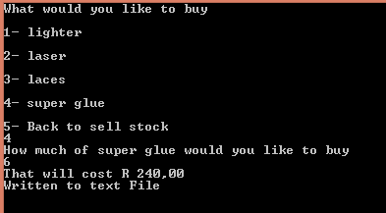

Sell shop menu

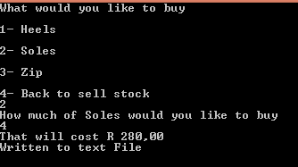

Sell repairs menu

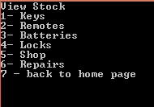

View Stock menu

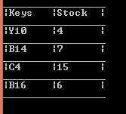

View Keys stock

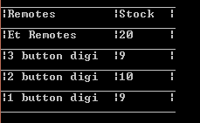

View remotes stock

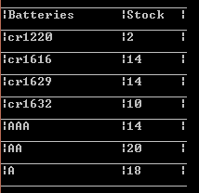

View batteries stock

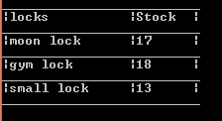

View locks stock

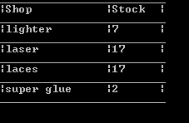

View shop stock

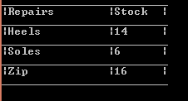

View Repairs

## Error Handling

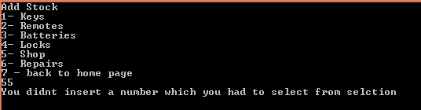

Error handling on add stock

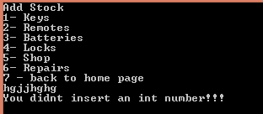

Error handling on add stock

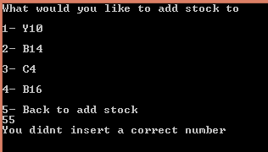

Error handling on add keys

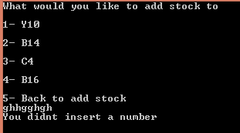

Error handling on add keys

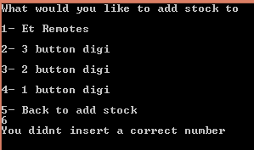

Error handling on add remotes

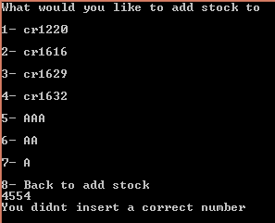

Error handling on add batteries

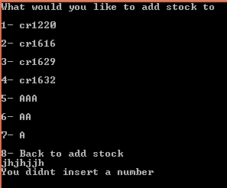

Error handling on add batteries

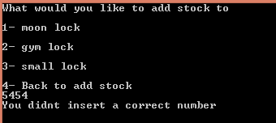

Error handling on add locks

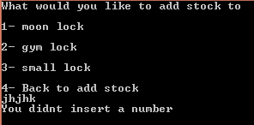

Error handling on add locks

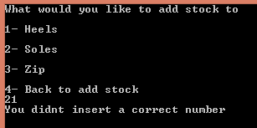

Error handling on add locks

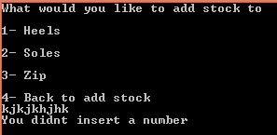

Error handling on add locks

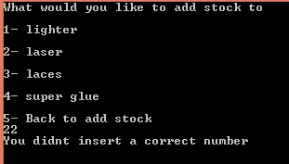

Error handling on add shop

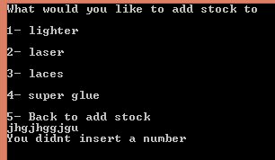

Error handling on add shop

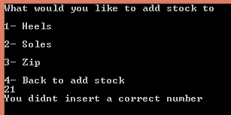

Error handling on add repairs

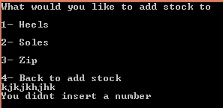

Error handling on add repairs

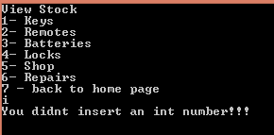

Error handling on view stock

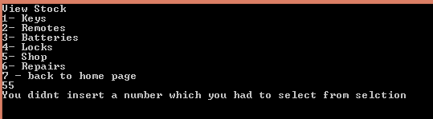

Error handling on view stock

# Specifications

Use Console-based menus to navigate between the functionality offered by the application.

At least one (1) menu option should allow the user to capture input.

Input should be stored in arrays (where appropriate). At least one (1) two-dimensional array should be used.

At least one (1) menu option should allow the user to view a report based on the captured input.

The report should be appropriately formatted and displayed on the Console window.

Predefined methods of the string should be used when generating/ displaying the report.

Appropriate if…else statements and loops should be used to process the data in order to generate the report.

# Diagrams

## prjLockStock Class Diagram

|  |
| --- |
| prjLockStock |
|  |
| +addBatteries ()  +addKeys()  +addLocks()  +addRemotes()  + addRepairs()  + addShop()  + addStock()  + Choice(input : Integer)  + displayBatteries()  + displayKeys()  + displayLocks()  + displayRemotes()  + displayRepairs()  + displayShop()  + displayStock()  + sellBatteries()  + Program()  + sellBatteries  + sellKeys  + sellLocks  + sellRemotes |

## C:\Users\15009851\Documents\Use Case assigment 1.pngUse Case Diagram

## Flow Chart

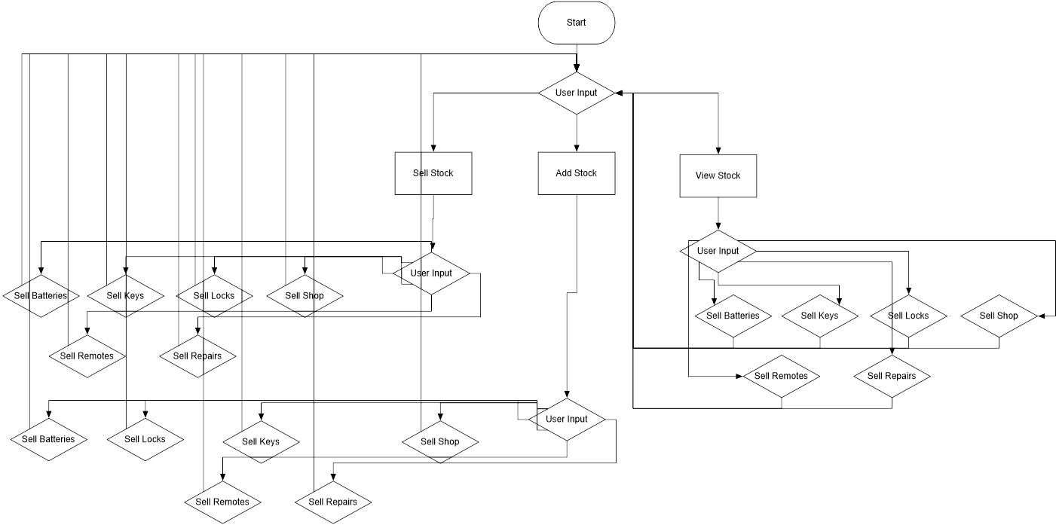

# Help

Follow the given instructions and input options in the console.

On start you’ll be given a menu with 3 options, sell stock, add stock, view stock.

## On start

1 –Add stock

2 – Sale

3 – View stock

99 - exit

## For add stock

1 – Keys

2 – Remotes

3 – Batteries

4 – Locks

5 – Shop

6 – Repairs

7 – Back to home screen

### For add keys

You’ll be promoted on the different keys to add.

And there will also be an option to go back to add stock screen.

### For add remotes

You’ll be promoted on the different remotes to add.

And there will also be an option to go back to add stock screen.

### For add Batteries

You’ll be promoted on the different batteries to add.

And there will also be an option to go back to add stock screen.

### For add locks

You’ll be promoted on the different locks to add.

And there will also be an option to go back to add stock screen.

### For add shop

You’ll be promoted on the different shop to add.

And there will also be an option to go back to add stock screen.

### For add repairs

You’ll be promoted on the different repairs to add.

And there will also be an option to go back to add stock screen.

### For back to home screen

You’ll be taken back to the home screen.

## For sell stock

1 – Keys

2 – Remotes

3 – Batteries

4 – Locks

5 – Shop

6 – Repairs

7 – Back to home screen

### For sell keys

You’ll be promoted on the different keys to sell.

And there will also be an option to go back to sell stock screen.

### For add remotes

You’ll be promoted on the different remotes to sell.

And there will also be an option to go back to sell stock screen.

### For add Batteries

You’ll be promoted on the different batteries to sell.

And there will also be an option to go back to sell stock screen.

### For add locks

You’ll be promoted on the different locks to sell.

And there will also be an option to go back to sell stock screen.

### For add shop

You’ll be promoted on the different shop to sell.

And there will also be an option to go back to sell stock screen.

### For add repairs

You’ll be promoted on the different repairs to sell.

And there will also be an option to go back to sell stock screen.

### For back to home screen

You’ll be taken back to the home screen.

## For view stock

1 – Keys

2 – Remotes

3 – Batteries

4 – Locks

5 – Shop

6 – Repairs

7 – Back to home screen

### Keys

You’ll be taken to a screen where it shows the keys and their stock.

Press enter after this to go back to view stock.

### Remotes

You’ll be taken to a screen where it shows the remotes and their stock.

Press enter after this to go back to view stock.

### Batteries

You’ll be taken to a screen where it shows the batteries and their stock.

Press enter after this to go back to view stock.

### Locks

You’ll be taken to a screen where it shows the locks and their stock.

Press enter after this to go back to view stock.

### Shop

You’ll be taken to a screen where it shows the shop items and their stock.

Press enter after this to go back to view stock.

### Repairs

You’ll be taken to a screen where it shows the keys and their stock.

Press enter after this to go back to view stock.

### Back to home screen

You’ll be taken back to the home screen.